LAB 3.1 (4.0 HOURS)

**Assessment Preparation Checklist:**

To prepare for the assessment, read Chapter 6 in the textbook, *Starting Out with Visual Basic® 2012*. This chapter examines how to write general-purpose procedures and functions. In addition, go through the lesson for this module that explores how to create, call, and pass arguments to the procedures as well as various techniques for debugging applications that use them.

**Title: Build a Hospital Charges Application**

In this lab, you will create an application that calculates the total cost of a hospital stay.

**Required Setup and Resources:**

* VMware Player 5.x
* ITT-Lab VM

**Recommended Procedure:**

Create an application that calculates the total cost of a hospital stay. The application should accept the following input:

* The number of days spent in the hospital, as an integer
* The amount of medication charges
* The amount of surgical charges
* The amount of lab fees
* The amount of physical rehabilitation charges

The hospital charges $350 per day. The application form should resemble the one shown in Figure:

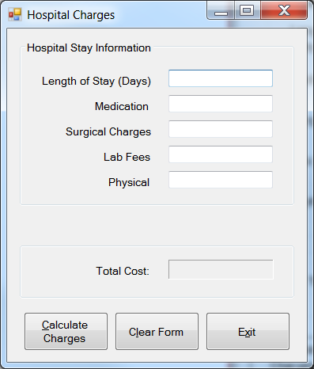

Create the following functions:

* CalcStayCharges: Calculates and returns the base charges for the hospital stay. This is computed as $350 times the number of days in the hospital.
* CalcMiscCharges: Calculates and returns the total of the medication, surgical, lab, and physical rehabilitation charges.
* CalcTotalCharges: Calculates and returns the total charges.
* ValidateInputFields: Checks the validity of the input fields by converting each to a numeric value and checking its range. If any input field is found to be invalid or empty, this function displays an error message and returns the value as False.

Make a note of the following points for input validation:

* Do not accept a negative value for length of stay, medication charges, surgical charges, lab fees, or physical rehabilitation charges.
* When displaying error messages, use a Label control and specifically name the missing field and the type of data to be entered (integer or numeric).

**Submission Requirements:**

Submit the completed project files to your instructor for grading. The completed project files package should include all the source files used to develop the application.

**Evaluation Criteria:**

Your submission will be evaluated against the following points:

* Does your application calculate and display the correct total cost according to the selected length of stay and various other charges?
* Does your application perform input validation and display a message with the name and data type for missing or invalid fields?
* Does your application clear the form when an appropriate button is clicked?